Ms. Saloni Anil Bhatt
Session No.: 1
F/Up: 19/06/2026
Date: 09/06/2026
(MSc. Clinical Nutrition & Dietetics)
E-mail: bouncethepound@gmail.com
Contact: +91 7045338184

Name: |  | Mrs. Ishwari Zope
Weight: |  | 81.00 kgs (home)
Case: |  | k/c/o PMOS (irregular periods + high testosterone + bulky ovaries + hirsutism + acanthosis nigricans) + hyperprolactinemia + zero trimester + fat loss + muscle gain
Triggers: |  | --
Diet Type |  | Non-Vegetarian
Eliminations/ Aversions |  | - All forms of sugar (white sugar + jaggery + honey + maple syrup)  - Lessen gluten products (whole wheat + dalia + rava + maida + barley)
Goals |  | - To attain fat loss (toning)  - Zero trimester
THINGS TO REMEMBER |  | - 3 – 3.5 Liters Water daily  - Follow Circadian Rhythm (Same sleep- wake – meals timings)  - Slow chewing (15-20 mins / meal)  - 60 mins of Physical activity + 15-15-15 mins walk post breakfast, lunch and dinner  - Make sure to have a ratio of 2 parts vegetables to 1 part carbohydrates.
Medicines/ Supplements |  | - Folinext – post lunch for 3 months  - Evion 400 – post lunch – 30 days  - Zincovit – post breakfast – 30 days-- daily
 | Issue | Strategy
 | Anxiety | 10 mins deep belly breathing (morning & night) + limit screen time at night
 | Sleep | Keep dinner light & early, avoid caffeine post 2pm, try warm milk + nutmeg or chamomile tea
 | Acidity | Avoid raw onions/garlic, fried snacks, long gaps between meals; use cumin, ajwain, fennel
 | Egg Quality | Avoid plastic containers, reduce xenoestrogen exposure (like soy-based processed foods, pesticides)

FAT LOSS DIET
MEAL TYPE | TIME | MENU
ON RISING | 6.30 - 7.30 am | 1 glass cinnamon fennel seeds water (you can prepare it at night and keep it in refrigerator and add fresh lime to it in the morning)
PRE-WORKOUT | 7.00 – 8.00 am | 4 almonds + 2 walnuts + 1 black date + 1 tsp ghee + 1 cup warm water
*WORKOUT — 9.00 AM – 10.00 AM — 60 MINS*
BREAKFAST | 10.00 am | 1 mug spearmint tea (brand- Tea curry)  +  MON-TUE-WED: 1 egg whole + 1 egg white (cooked in your style) + 1-2 fruit  OR  THU (fast day): 1 bowl sweet potato pomegranate chaat  OR  FRI-SAT: 2 moong dal chilla/ besan chilla + green chutney + 1 fruit  OR  1 bowl boiled moong/ chana chaat (add pomegranate / apple on it)  OR  SUN: 1 bowl green peas vegetable poha/ green peas vegetable upma
*PLEASE DO NOT SLEEP/ SIT IMMEDIATELY—WALK FOR 10- 15 MINS POST BREAKFAST—COMPULSORY*
MID-MORNING | 12.00 pm | 1 glass vegetable juice (pomegranate + beetroot + carrot + amla; sieve it)
PRE-LUNCH | 5-10 mins before lunch | 1 glass water
LUNCH | 1.00 pm | 2/WEEK: 1 bowl koshimbir + 1 bowl dal / pulse curry (moong, matki, rajma, chole; low oil; squeeze half a lime on it for better iron absorption) + ¾ bowl rice + 1 glass buttermilk  OR  1/WEEK: 1 bowl kachumber (sprinkle sesame seeds on it) + 1 bowl green subji (lauki, tindi, bhindi, pumpkin, gavar, french beans, karela, low oil) + 1 roti + 1 glass buttermilk/ 1 katori curd  OR  1/WEEK (compulsory): 1 bowl kachumber (sprinkle sesame seeds on it) + 1 bowl cruciferous subji (cabbage/ cauliflower, low oil) + 1 ragi bhakri + 1 glass buttermilk/ 1 katori curd  OR  2/WEEK (compulsory): 1 bowl kachumber (sprinkle sesame seeds on it) + 1 bowl green leafy vegetable subji (palak/ methi/ shepu/ lala math/ bathua, low oil) + 1 roti + 1 glass buttermilk/ 1 katori curd  OR  1/WEEK: 1 bowl kachumber (sprinkle sesame seeds on it) + 1 bowl rice + 1 bowl chicken curry (100gms chicken)/ fish curry (120gms fish)  OR  ON THU: 1 bowl sama khichdi + 1 bowl vrat ki kadhi
Make sure you feel light after lunch & half your plate should be filled with vegetables
*PLEASE DO NOT SLEEP/ SIT IMMEDIATELY — WALK FOR 10–15 MINS POST LUNCH — COMPULSORY*
POST LUNCH | Finish between 2.30 - 5.30 pm | 1-1.5 litres of water (add 1 tsp chia seed)
EVENING | 4.00 – 6.00 pm | 1 mug spearmint tea (brand- Tea curry)  +  1 fruit (AVOID mango, banana, chikoo, grapes, custard apple, jackfruit, lychee) + 2 prunes  +  1 tbsp sunflower seeds (as per seed cycling) / 1 handful chana peanuts (50:50)
AVOID FRIED AND SUGARY SNACKS
PRE DINNER | 5-10 mins before dinner | 1 glass water
DINNER | 7.30 – 8.30 pm | 2/WEEK: 1 bowl kachumber/ vegetable stir fry + 1 portion chicken tikka (75gms boneless chicken)  OR  2/WEEK: 1 bowl koshimbir + 1-2 moong dal chilla/ besan chilla + green chutney [prepare more batter here for next day’s breakfast]  OR  1/WEEK: 1 bowl mix veg soup/ palak tomato soup + 3-4 pcs palak moong dal tikkis / lauki paneer tikkis + green chutney  OR  2/WEEK: 1 bowl vegetable khichdi / pumpkin khichdi + 1 bowl curd/ kadhi  OR  ON THU: 2 rajgira carrot thalipeeth + green chutney + 1 katori curd
PLEASE DO NOT SLEEP/ SIT IMMEDIATELY—WALK FOR 15-20 MINS POST DINNER—COMPULSORY
BED TIME | 11.00 pm | 1 tsp saunf (chew it) + 1 tsp ajwain (gulp it) + 1 glass water
A bedtime time routine for us
- Kindly put your phone, laptop, and TV away 60 before going to bed and allow yourself to slowly switch off for the day
- Wash your face, brush your teeth, and get into comfortable sleepwear
- Dim the lights and create a calm, cozy environment. You can read a book if you want
- Spend 5-10 minutes doing some light stretching or gentle yoga
- Try a 10 min guided meditation, deep breathing exercise, or a few minutes of Om chanting
- Take your magnesium relax supplement
- Once in bed, wear an eye mask or cover our eye with handkerchief and focus on slow breathing or try reverse counting from 100 or 50 to help quiet the mind
Aim to sleep and wake up around the same time each day :)
BONUS TIP: Add turmeric + black pepper to your lunch (turmeric reduces systemic inflammation that impacts implantation)
Prepare our body for deep sleep and hormone repair — because we can’t heal if we’re wired, scrolling, or overstimulated at night
Dim lights at least 90 mins before bed—this signals melatonin, which supports progesterone and uterine lining quality
Reset our nervous system:
- Spend 5–10 mins with legs up the wall to calm the body and support blood flow to our reproductive organ
- Or, just write down 3 things that made us feel peaceful today.
- No scrolling phone after 9PM: Instead, listen to calming music, read a little, or simply sit quietly and relax :)
More tips:
- Don’t fast during burnout: Fasting can delay ovulation if our adrenals are stressed.
- Breathe before meals: Just 3 deep belly breaths boost digestion and lower inflammation.
- Nourish, don’t restrict: Our body needs to feel fed and safe to support new life.

PERIOD TRACKER
DATE | NO. OF DAYS | PMS
9th Feb 2026
19th Apr 2026
12th May 2026

Vitamin B6–Rich Foods | Iron-Rich Foods
Banana | Spinach (Palak)
Chickpeas (Chana) | Lentils (Moong, Masoor, Toor)
Potatoes | Chickpeas (Chana)
Peanuts | Kala chana
Sunflower seeds | Beetroot
Whole wheat roti | Rajma
Brown rice | Jaggery
Spinach (Palak) | Dates
Egg yolk | Raisins
Fish | Garden cress seeds (Halim)
Chicken liver | Egg yolk
— | Fish
— | Chicken liver

HERE I AM SHOWING YOU HOW YOUR LUNCH & DINNER PLATE SHOULD LOOK LIKE :-
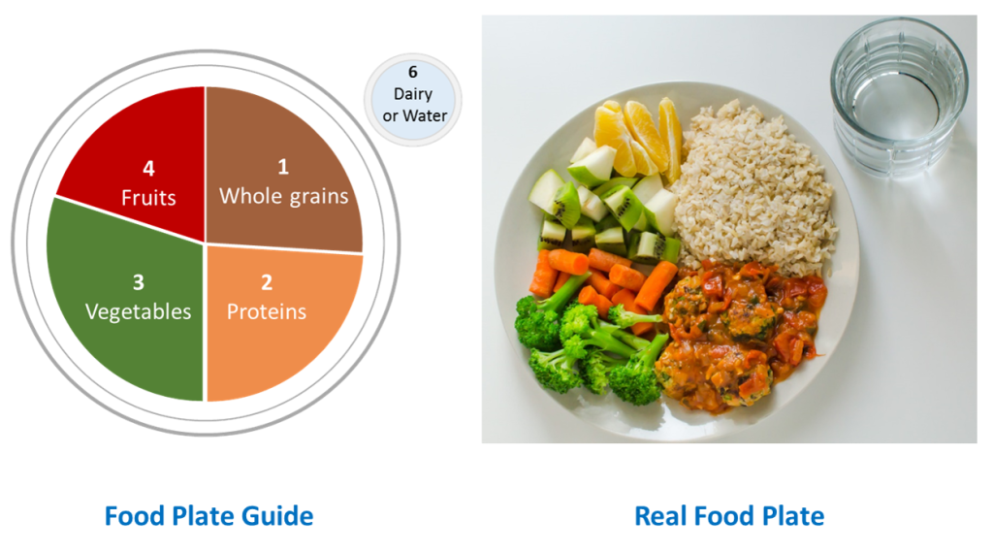
*NOTE*
- KINDLY MAINTAIN PORTION SIZES AND CHEW THE MEALS WELL. Here’s why:
The reason is that it takes about 20 minutes for our brains to register that we’re full. If we eat fast, we can continue eating past the point where we’re full. If we eat slowly, we have time to realize we’re full, and stop on time. Hence, now eating slowly should be a part of your new lifestyle.

- MEASUREMENTS:
- 1 bowl = 200 ml bowl
- 1 katori = 100 ml bowl
- Oil= 3 tsp/ day (cold pressed groundnut/ sesame / mustard/ avocado oil for cooking; brand- Gramiya)
- Sugar/ jaggery/ honey= 2 tsp/ day (if recommended)
- Salt= 2 tsp/ day
- Water= 12-15 glasses/ day

- POINTERS:
- It is important to have small frequent meals; hence do not miss any mid meals
- If you miss any meal; you will tend to eat more in the coming meal
- Opt for 1 glass lime water soda (sour)/ diet coke if needed
- Please maintain portion sizes compulsorily
- If you feel hungry in between these meals, first drink a glass of water
- Make sure you feel light after each meal
- It is best to avoid potato while on an active weight loss journey.
- Read the diet plan thoroughly and follow each meal and supplement as mentioned.
- Kindly chew your meals properly. Each main meal should take 15-20 mins to eat.
